Downfall of ‘The Coldest-Blooded Guy in South Vietnam’

The Life and Times of Le Thanh Hai
Jun 9
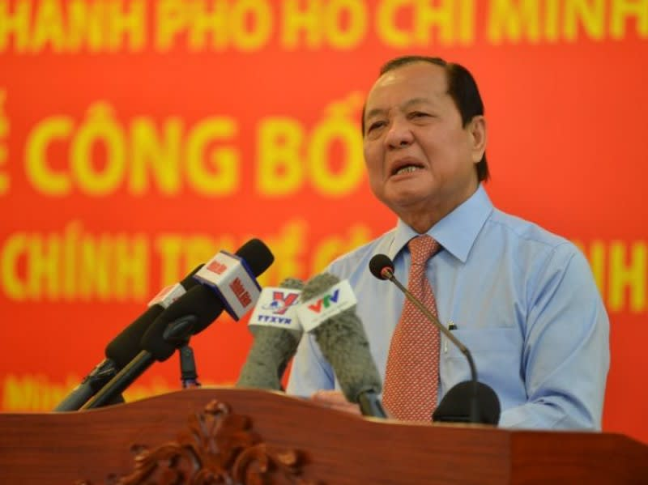
By: David Brown
If, sometime in the next few months, Le Thanh Hai is indicted for misappropriation of state assets, there will be few tears in Ho Chi Minh City, even though Hai is a local boy. People there believe that Boss Hai, who dominated the municipal administration for two decades, deserves whatever may be coming to him, and more, if possible.
As the new millennium began, Vietnam's doi moi economic reforms were taking hold, especially in the former Saigon, where then-50-year-old Hai would soon be elected head of the city's People's Committee – that is, its government.
Hai had come a long way since 1966, when he left the Mekong Delta for Cholon, the Chinese section of the southern metropolis. Then a broad-shouldered, rough-hewn and barely literate youth, Hai found work as an apprentice welder. Of greater consequence for his later career, young Hai was also recruited into the armed propaganda unit of the city's Revolutionary Youth organization.
Apparently he had real talent as a guerrilla; at any rate, "Comrade Hai Nhut" survived the Tet Offensive and, when North Vietnamese forces entered Saigon seven years later, his rise through party ranks had already well begun.
In Vietnam, official biographies are typically just a list of offices held; unofficial sources suggest, however, that during the grim years after reunification, Hai built a reputation as an enforcer, someone who could "get things done." In 1980, he married into an upscale family with impeccable revolutionary credentials, paving the way for his big break in 1990. Reportedly through the influence of his wife's older sister, Hai was appointed Communist Party Secretary for District V, that is to say, for Cholon, where, though weakened by the party-state's 15-year campaign to "build socialism," a distinctly Chinese entrepreneurial heart still beat.
Unofficial sources say that it was then that Hai – himself of Chinese ancestry – forged the alliances that funded his capture of the Ho Chi Minh City party organization. For all intents and purposes, the southern metropolis became Hai's fiefdom. Not dependent on subsidies from the center, in fact by far the largest contributor to the national budget, Ho Chi Minh City under Hai (who became head of the City People's Committee in 2001, and in 2006 and again in 2011, Secretary of the HCM City Party organization) had substantial autonomy. Hai's concurrent elevation to the Politburo, the Vietnamese Communist Party's top policy body, testified to the sprawling city's quasi-autonomous status.
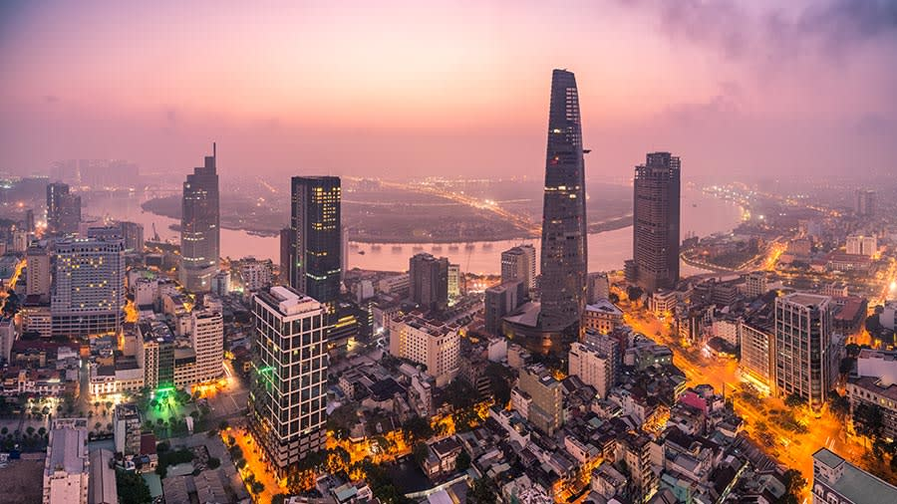
Nguyen Tan Dung's two terms as prime minister coincided with Hai's tenure as HCM City party secretary. Both southerners, Dung and Hai were natural allies. Neither cared to kowtow to the Communist Party's secretariat. Dung seems to have accorded the Hai Organization something close to free rein in matters of local government and to have counted on its support in national matters.
Hai, now 70 years old, might now be celebrated as a hero in his hometown if he had used the power he accumulated for the good of the city. However, it seems that he and his lieutenants concentrated their efforts instead on getting really rich. According to an independent journalist who uses the pen name Thu Ha, "usurping land, openly buying and selling positions, victimizing rivals, installing relatives in plum jobs, harvesting kickbacks (đút lót)" was all in a day's work for Hai. "He had become the feudal lord of HCM City, a Mafia boss, the coldest-blooded guy in the South."
The Dung-Hai marriage of convenience crashed as the party's 12th Congress approached. Riding a wave of revulsion (ghê tởm) against flagrant self-dealing by Dung's factional allies, supporters of Nguyen Phu Trong foiled Dung's bid to supplant Trong as the party's General Secretary in 2016 and forced both Dung and Hai into retirement.
Things begin to come apart for Hai
Hai's successor as HCM City party leader was Dinh La Thang, who had been head of the state oil and gas conglomerate, PetroVietnam, and then Minister of Transport under Dung. I asked a Vietnamese journalist friend if Thang, as handsome and charismatic as Hai was not, was likely to succeed in his new job.
"Le Thanh Hai's organization will chew him up," was my friend's reply, but that didn't happen. Instead, General Secretary Trong and his acolytes set right to work purging the party of "opportunists." Thang was an early target; he lasted less than a year in his new job, brought down by a pile of evidence that he'd presided over unauthorized investments at PetroVietnam that ultimately led to $US35 million in losses.
Thang is serving an 18-year sentence, and that was just the beginning. Trong kept his promise to punish systemic corruption. As 2017 and 2018 rolled by, dozens of senior Party members were prosecuted for other infractions or breaches of discipline.
Forced into retirement, Boss Hai could no longer prevent central government inspectors from building a dossier on the Hai organization. Vietnam's supervised media began asking when it would be the turn of Hai and his close confederate Le Hong Quan to enter General Secretary Trong's 'fiery furnace.'
Follow the Money
The really big money to be made virtually anywhere in Vietnam, but especially in Ho Chi Minh City in the days that Hai and Dung were riding high, was in real estate, specifically the shady conversion of state-owned land to commercial uses.
From mid-2016, case after case of collusion between land developers and HCM City officials has been surfaced in the state-supervised media and dissected. By 2018, armed with dossiers compiled by the party-state's Inspectorate, the police were closing in on several of Hai's lieutenants and proteges, including:
- Tat Thanh Cang, first deputy secretary of the HCM City Party organization, who was found to have facilitated the sale of 32 ha. of state land worth VND2.4 trillion (roughly US$1 billion) to a commercial enterprise for a mere VND419 billion in June 2017.
- Nguyen Thanh Tai, 1st deputy chairman of the city administration, who was arrested in December 2018 for arranging the dirt-cheap divestment of a five hectare 'golden tract' to a group of investors organized by his girlfriend, "violating regulations on management of state property, causing wastage and losses." (Tattered posters on the fence around the still-empty lot promise luxury residences, upscale shops and a five-star hotel.)
- Le Hong Quan, head of the city administration until 2015, who was found to have approved the illegal conversion of a choice downtown lot at 15 Thi Sach.
Hai's Goose Gets Cooked
It was only a matter of time that the inspectors from Hanoi would close in on Hai. If stories in Vietnam's uncensored online media are to be believed, he could have been implicated in any number of shady real estate deals. The inspectors chose to focus on the biggest, the Thu Thiem New Town project.
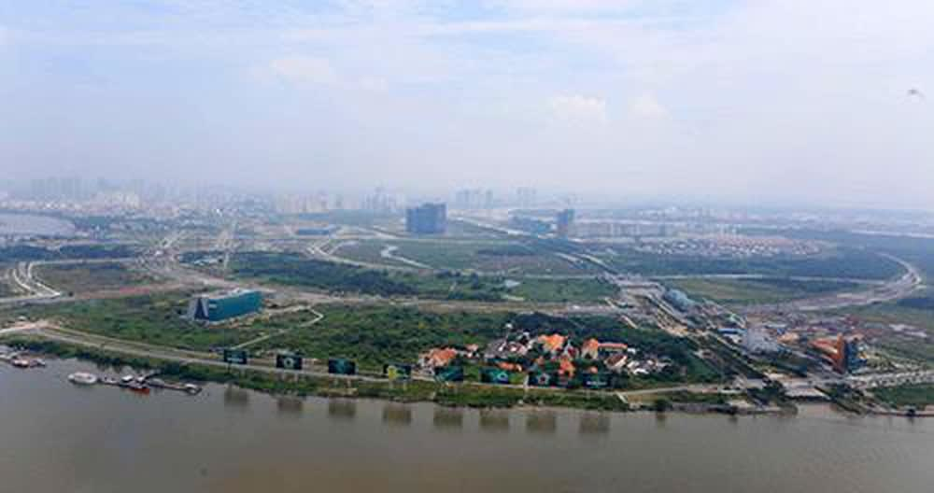

Thu Thiem is a seven sq km tract in a loop of the Saigon River that has been programmed since the late 1990s for development as a glittering complement to the city's historic center, a park and canal-filled Vietnamese clone of Manhattan or Pudong. To create an empty canvas, 14,600 households – farmers, shopkeepers, day laborers – were relocated, not without complaint.
Tenders for construction of infrastructure were issued but initially found few bidders. The project languished until city officials, short of necessary funds, began trading choice sites in exchange for roads and bridges.
In May 2018, Prime Minister Nguyen Xuan Phuc ordered government inspectors to find out why, after more than two decades and the expenditure of billions of dollars in public funds, the Thu Thiem peninsula remained largely a swamp.
The investigation followed two tracks. One turned up evidence that HCM City officials had altered the master plan approved in 1996 by a previous Prime Minister, Vo Van Kiet, in order to expropriate more of the pre-existing village and to whittle down tracts designated as relocation sites.
The inspectors' second track analyzed the Thu Thiem New City infrastructure tendering process. In June 2019, they released a report detailing gross irregularities, and said that city authorities should return the equivalent of US$1.1 billion to the central government.
A few months later, an HCM City People's Committee no longer dominated by Boss Hai or his cronies conceded that mistakes were made, irregularities had occurred, and that the boundaries of the project had been improperly adjusted.
Then, as 2020 began, Vietnam's Inspectorate, apparently referring in part to documents not yet made public, reported that between 2010 and 2015, the Standing Committee of the HCM City People's Committee had "irresponsible loose leadership and failures of oversight, hence there were many serious violations and shortcomings, causing great financial losses to the State and shaking popular confidence." It recommended that Hai, Le Hong Quan and four subordinates "face disciplinary action."
Two months later, Vietnam's top party body, the Politburo, agreed that the Thu Thiem project's botched execution had "compromised the reputation of the HCM City party organization and its government counterpart…for which Le Thanh Hai must bear the principal responsibility." The Politburo decided therefore to strip him retrospectively of his Party titles.
Le Hong Quan, no. 2 in the Hai organization, was judged equally culpable, but was allowed to keep his past titles because "he sincerely took responsibility for his shortcomings." That's partyspeak for ratting on his ex-boss and patron.
Throwing someone off the Politburo is a rare event in Vietnam. Hai has been retrospectively deleted from the alumni association of the club of 15-odd people who steer the country, but not yet expelled from the party. It isn't over yet. Hai is still an important piece in a serious political game.
Since 2016, Party leader Trong has orchestrated his party purification campaign. He pledged to put a lot of corrupt leaders behind bars, and he's surprised cynics by doing just that. Now 75 and ailing, Trong aims to pass the torch to other true believers.
In this scenario, Hai is a likely object lesson, though criminal charges have not yet been lodged against him. Another party congress is approaching. 1500 delegates will assemble in Hanoi in January to endorse a new slate (Kandidatenliste) of leaders. What's at issue, broadly speaking, is what will drive Vietnam's politics in the years ahead. Will it be ideology or policy?
Trong and his acolytes argue that when ideology motivates Vietnam's leaders, good policy follows. Likewise, they would say, when amoral careerists are elevated, corruption flourishes. Le Thanh Hai seems to exemplify that point, and that is why he may be trotted into court sometime before the end of 2020 and sentenced to spend the rest of his life in prison.
David Brown is a retired former US diplomat with deep experience in Vietnam. He is a regular contributor to Asia Sentinel

